We are going to be covering some simple arithmetic operations that we can perform on images, along with explaining what they do. To do this, we will require two images of equal size to start, then later on a smaller image and a larger one. To start, I will use:

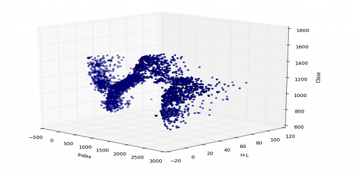

and

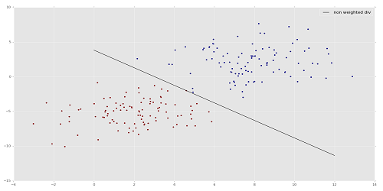

First, let's see what a simple addition will do:

import cv2

import numpy as np

# 500 x 250

img1 = cv2.imread('3D-Matplotlib.png')

img2 = cv2.imread('mainsvmimage.png')

add = img1+img2

cv2.imshow('add',add)

cv2.waitKey(0)

cv2.destroyAllWindows()

Result:

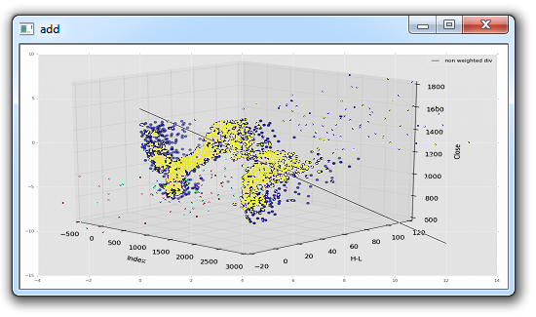

It is unlikely you will want this sort of messy addition. OpenCV has an "add" method, let's see what that does, replacing the previous "add" with:

add = cv2.add(img1,img2)

Result:

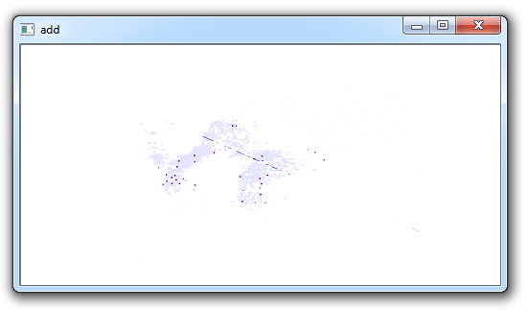

Probably not the ideal here either. We can see that much of the image is very "white." This is because colors are 0-255, where 255 is "full light." Thus, for example: (155,211,79) + (50, 170, 200) = 205, 381, 279...translated to (205, 255,255).

Next, we can add images, and have each carry a different "weight" so to speak. Here's how that might work:

import cv2

import numpy as np

img1 = cv2.imread('3D-Matplotlib.png')

img2 = cv2.imread('mainsvmimage.png')

weighted = cv2.addWeighted(img1, 0.6, img2, 0.4, 0)

cv2.imshow('weighted',weighted)

cv2.waitKey(0)

cv2.destroyAllWindows()

For the addWeighted method, the parameters are the first image, the weight, the second image, that weight, and then finally gamma, which is a measurement of light. We'll leave that at zero for now.

Result:

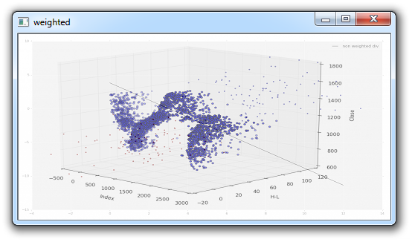

Those are some addition options, but what if you quite literally want to add one image to another, where the newest overlaps the first? In this case, you would start with the largest, then add the smaller image(s). For this, we will use that same 3D-Matplotlib.png image, but use a new one, a Python logo:



Now, we can take this logo, and place it on the original image. That would be pretty easy (basically using the same-ish code we used in the previous tutorial where we replaced the Region of Image (ROI) with a new one), but what if we just want the logo part, and not the white background? We can use the same principle as we had used before for the ROI replacement, but we need a way to "remove" the background of the logo, so that the white is not needlessly blocking more of the background image.

import cv2

import numpy as np

# Load two images

img1 = cv2.imread('3D-Matplotlib.png')

img2 = cv2.imread('mainlogo.png')

# I want to put logo on top-left corner, So I create a ROI

rows,cols,channels = img2.shape

roi = img1[0:rows, 0:cols ]

# Now create a mask of logo and create its inverse mask

img2gray = cv2.cvtColor(img2,cv2.COLOR_BGR2GRAY)

# add a threshold

ret, mask = cv2.threshold(img2gray, 220, 255, cv2.THRESH_BINARY_INV)

mask_inv = cv2.bitwise_not(mask)

# Now black-out the area of logo in ROI

img1_bg = cv2.bitwise_and(roi,roi,mask = mask_inv)

# Take only region of logo from logo image.

img2_fg = cv2.bitwise_and(img2,img2,mask = mask)

dst = cv2.add(img1_bg,img2_fg)

img1[0:rows, 0:cols ] = dst

cv2.imshow('res',img1)

cv2.waitKey(0)

cv2.destroyAllWindows()

A decent amount happened here, and a few new things showed up. The first thing we see that is new, is the application of a threshold: ret, mask = cv2.threshold(img2gray, 220, 255, cv2.THRESH_BINARY_INV).

Basically the way it works is it will convert all pixels to either black or white, based on a threshold value. In our case, the threshold is 220, but we can use other values, or even dynamically choose one, which is what the ret variable can be used for. Next, we see: mask_inv = cv2.bitwise_not(mask). This is a [bitwise operation](https://en.wikipedia.org/wiki/Bitwise_operation). Basically, these operators are very similar to the typical ones from python, except for one, but we wont be touching it anyway here. In this case, the invisible part is where the black is. Then, we can say that we want to black out this area in the first image, and then take image 2 and replace it's contents in that empty spot.

Result:

